Preliminary Project Definition

DATE: November 14, 2023

TO: Leonard Franklin Register

FROM: Ethan Nguyen

SUBJECT: Preliminary Project Definition

**INTRODUCTION**

**PROBLEM STATEMENT**

**Design Problem Description**

***Background Information***

At the University of Texas at Austin, in the Chandra Department of Electrical and Computer Engineering, Electrical and Computer Engineering students complete a capstone design project to concretely implement what they have learned in university. These students have three options in the formation of their groups, forming their own teams and proposing their own projects, forming their own teams and approaching faculty members who already have projects, and filling out a skills, preferences, and expertise form and being assigned to industry projects. This final option, the assignment of the residual students to industry projects is the subject of this project. In the current system, the technical professor of the senior design course manually looks through the form responses and manually forms the distribution of students to capstone design groups, a process that is tedious and time consuming. This project seeks to create a software program that, given the input of the preferences and expertise of the students, and the expertise requirements from the company, quickly creates an optimized distribution of students to groups, preventing bad outlier teams, accounting for willingness to work with NDA/IP agreements, and creating a best solution to place students with industry projects.

***Design Functionality***

***Relevant Standards***

***Ethical Considerations***

There are potential ethical considerations in the area of privacy in this specific design problem. The development of the design project virtually requires using previous data from previous years. When the form for group preferences was filled out, the students filling out the form were informed that only the professor would be able to see their answers. In regular use of the program, only the professor would be able to see their answers, but in developing this project, if previous years’ data is used, that would be a privacy violation. The data would need to be anonymized to prevent this.

***Project Deliverables***

At the conclusion of the project, we will deliver an downloadable executable Java file that, through receiving the correct inputs, will provide a corresponding output of the distribution of students to capstone groups according to the input and output specifications. We will also deliver along with this file all the code that the program uses and code documentation.

**Requirements Specification**

***Inputs and Output Specifications***

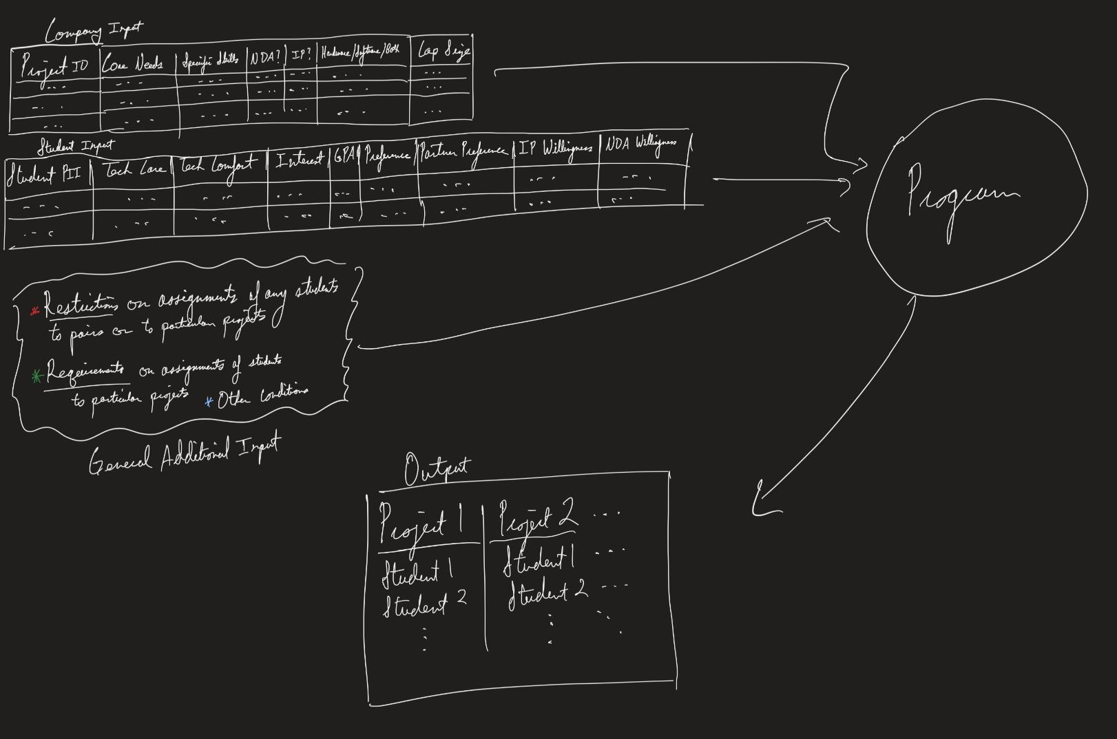

***User Interface Specifications***

User interface

***Operating Environment Specifications***

Operating environment

***Performance Specifications***

Once our program has outputted a distribution of teams with assigned students, the optimality of individual teams as well as, in consequence, the optimality of the entire distribution by which the performance of the program will be evaluated will take into account each corresponding company’s needs in its core area of undergraduate study, for expertise on specific topics, for the project’s nature, and for its NDA/IP requirements, and will quantify how well these needs match to the project’s students’ technical comfort, interest, and willingness as well as how well the students’ own preferences were met. These measures of optimality will likely be single numbers, ranging between 0 and 1, where a score of 1 suggests that all of a company’s needs and its students’ preferences have been fully met and a score of 0 suggests that either none of the needs of the company were met, whatsoever, or some other absolutely necessary condition for any assembled team was not fulfilled, such as, for example, the team’s total GPA not passing some absolutely necessary minimum threshold.

**TEAM ORGANIZATION**

**Project Roles**

Subteams, Additional Roles, Personnel

Ethan and Nathan Backend

Gabriel Frontend

Ethan Project Lead

Personnel -

| Name | Planned contributions | Areas of expertise | Related coursework |
| --- | --- | --- | --- |
| Ethan Nguyen |  |  | EE 422C (SOFTWARE DESIGN & IMPLEMENTATION II) |
| Nathan Stodola |  |  | EE 422C (SOFTWARE DESIGN & IMPLEMENTATION II)  EE360G (Programming Paradigms) |

| Name | Planned contributions | Areas of expertise | Related coursework |
| --- | --- | --- | --- |
| Gabriel Mount |  |  | ECE 461L (Software Engineering and Design Laboratory) |

**Team Policies**

***Project Management Tools/Platforms***

The team will use Discord for all strictly internal team communication including virtual meetings and regular text communication. The team will keep track of tasks through meeting summary documents posted by our secretary, Nathan Stodola. Scheduling of meetings, events, and due dates will occur on Google Calendar. Documentation management will occur in GoogleDocs in a shared Google Drive for organization.

***Team Expectations***

Do some stuff

***Conflict Resolution***

Resolve some conflicts

**CONCLUSION**

Something

**REFERENCES**

**APPENDIX A: APPLICABLE STANDARDS**